**4.2.1 LEARNING RESOURCE CENTER**

**LRC Entrance Gate**

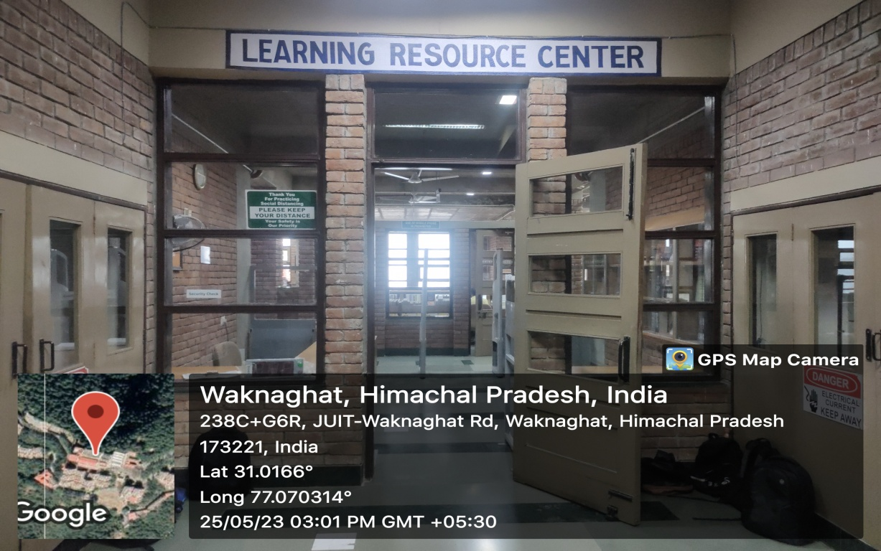

**Property Counter**

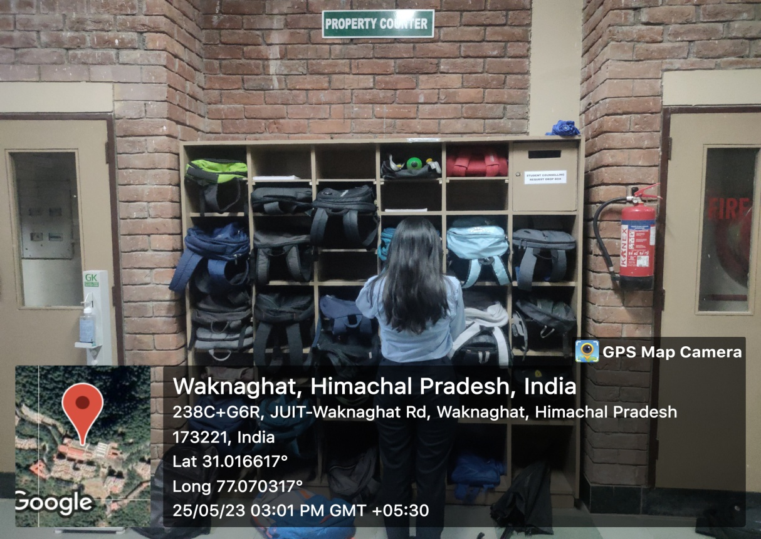

**Security check**

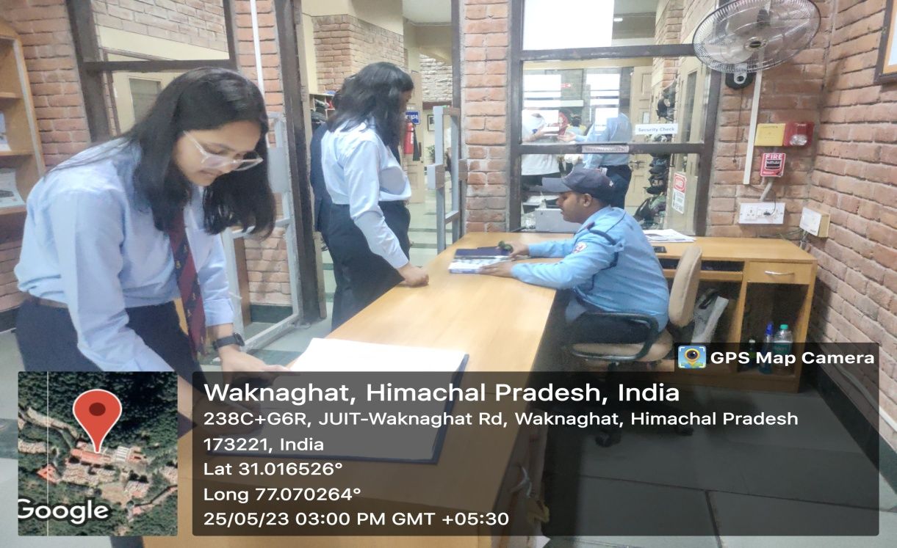

**3 M Security Systems**

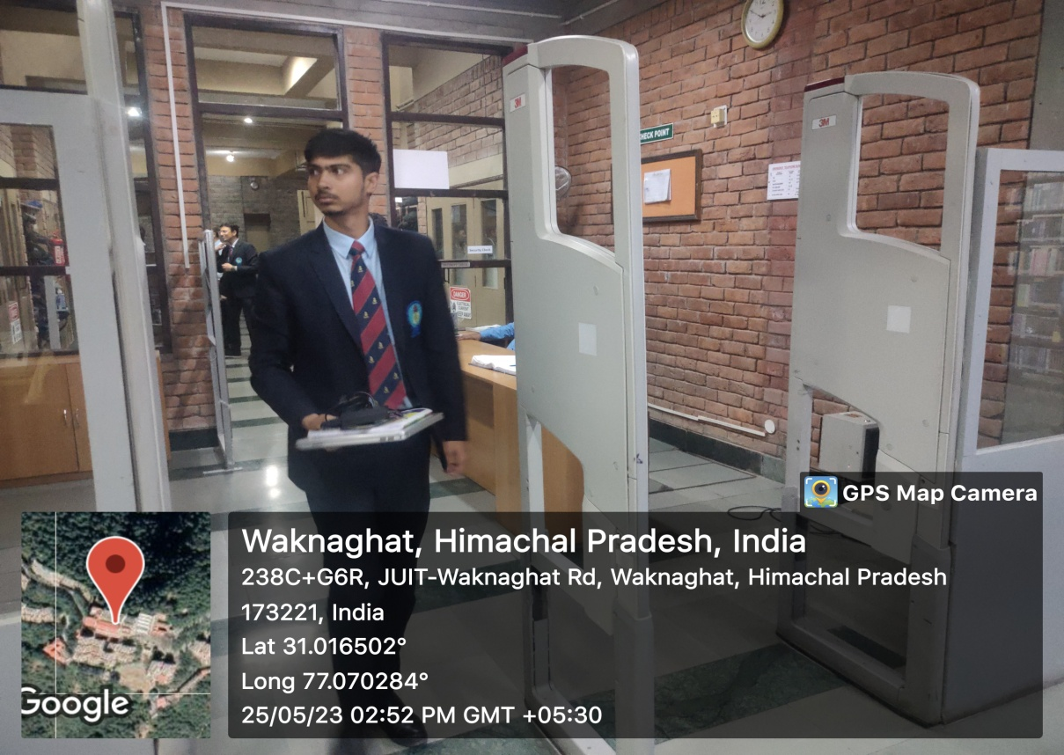

**OPAC System**

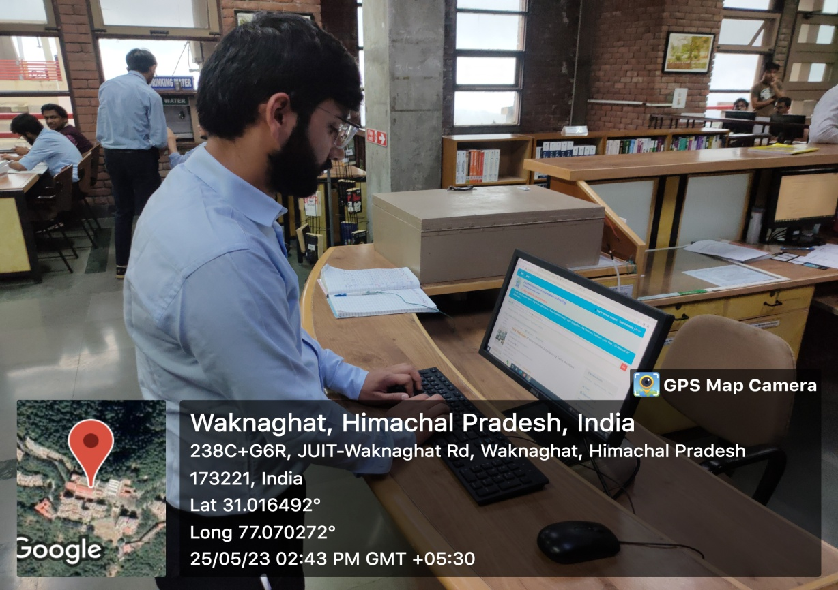

**Visually Impaired Users’ Systems** 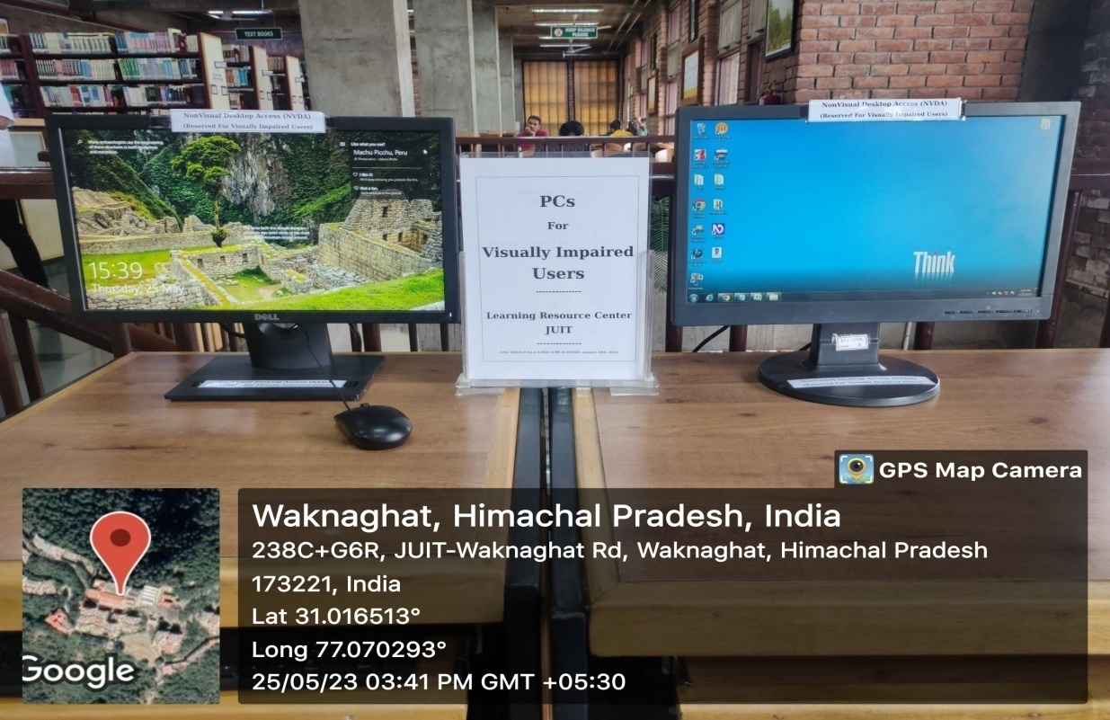

**Periodicals Display** 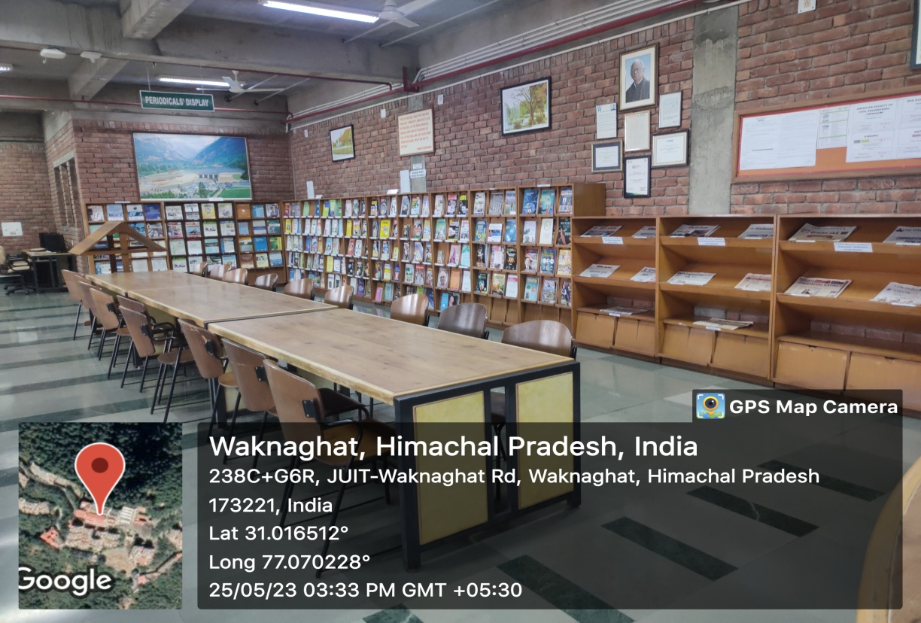

**Reading Area**

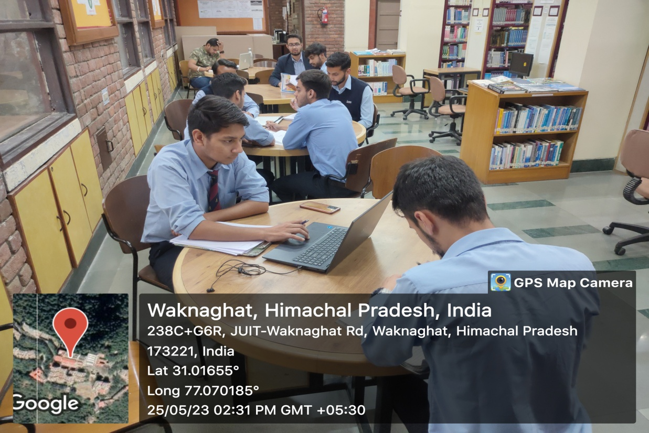

**Circulation Counter – Image 1**

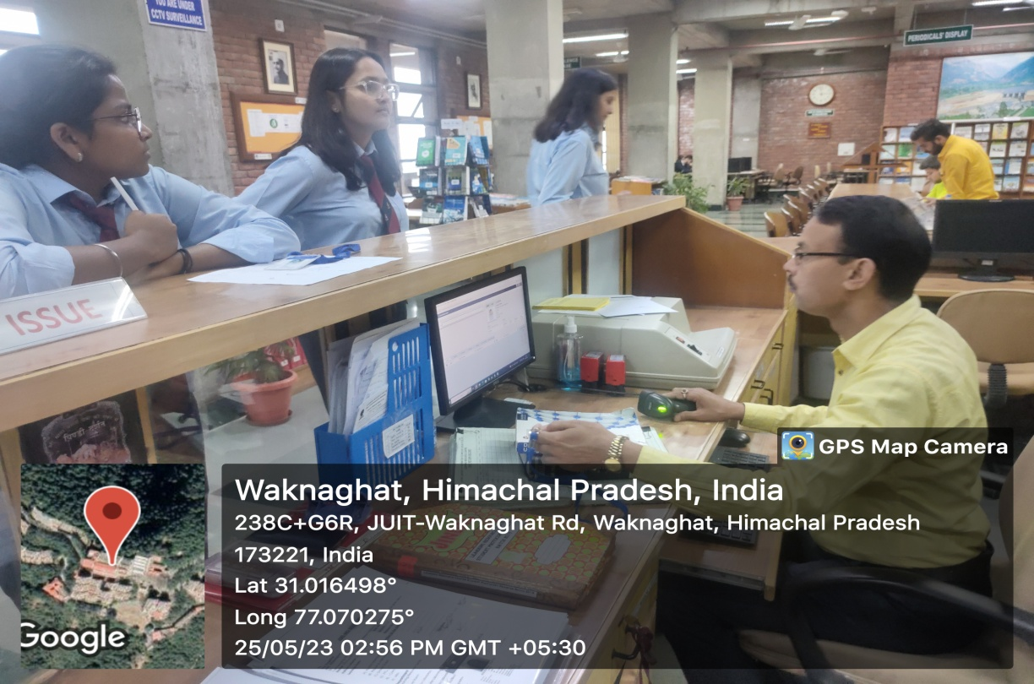

**Circulation Counter – Image 2**

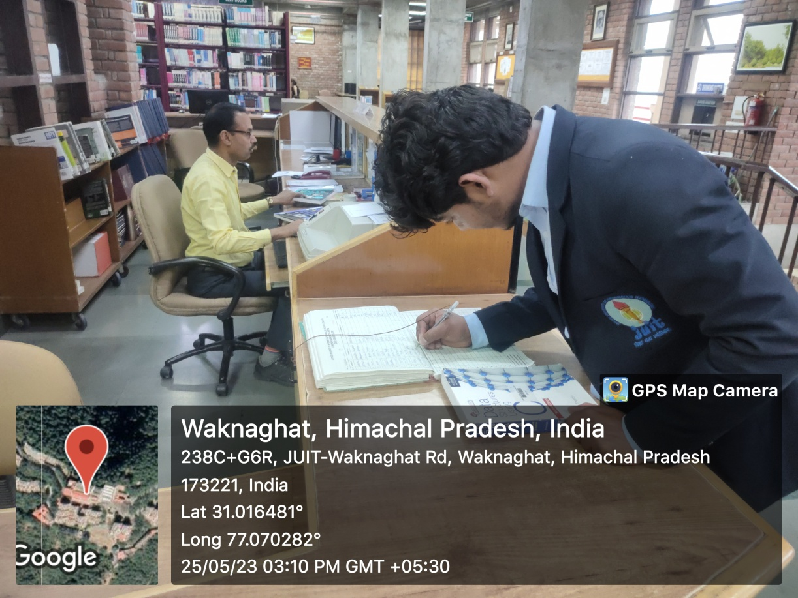

**Circulation Counter Help Desk**

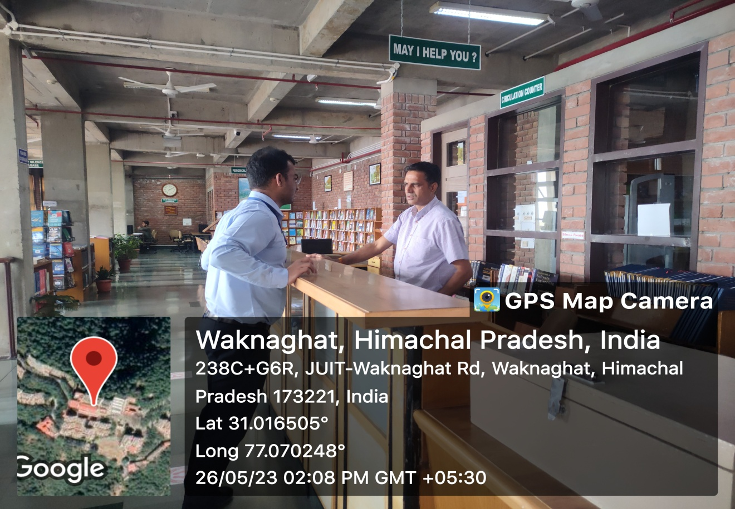

**Wi-Fi Facility in the Library**

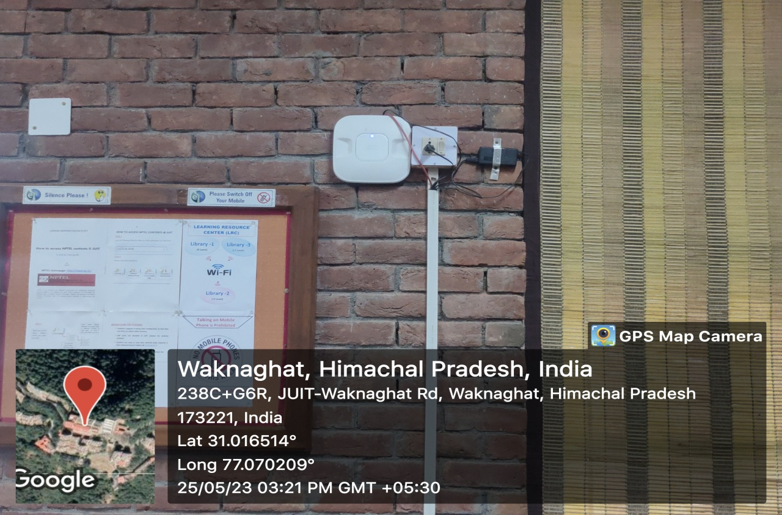

**Computer Access Facility in the Library – Image 1**

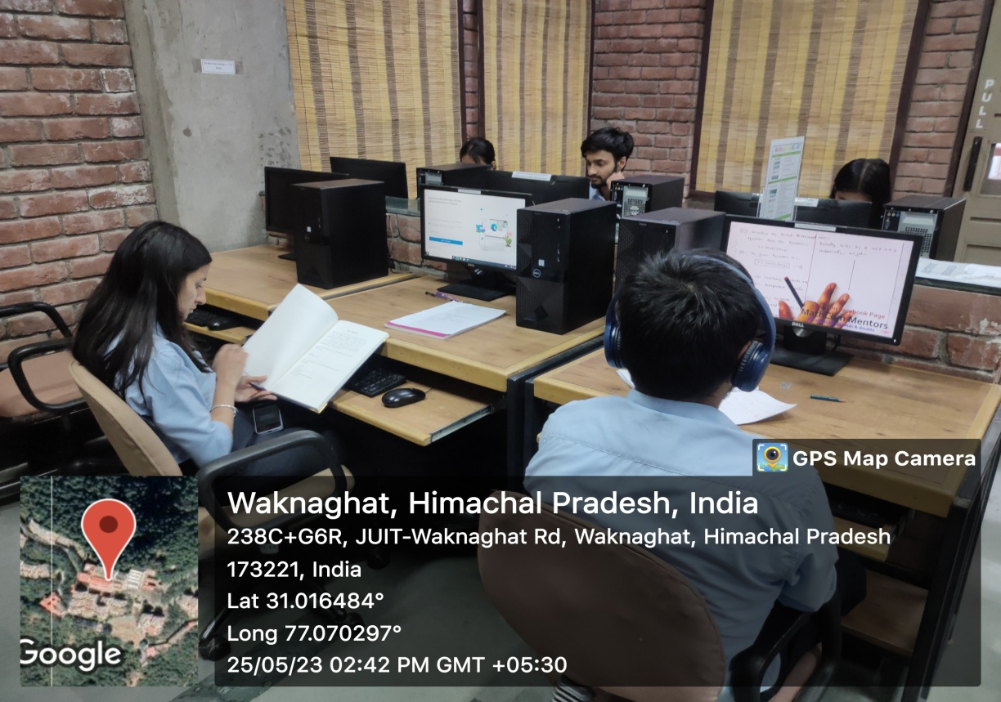

**Computer Access Facility in the Library – Image 1**

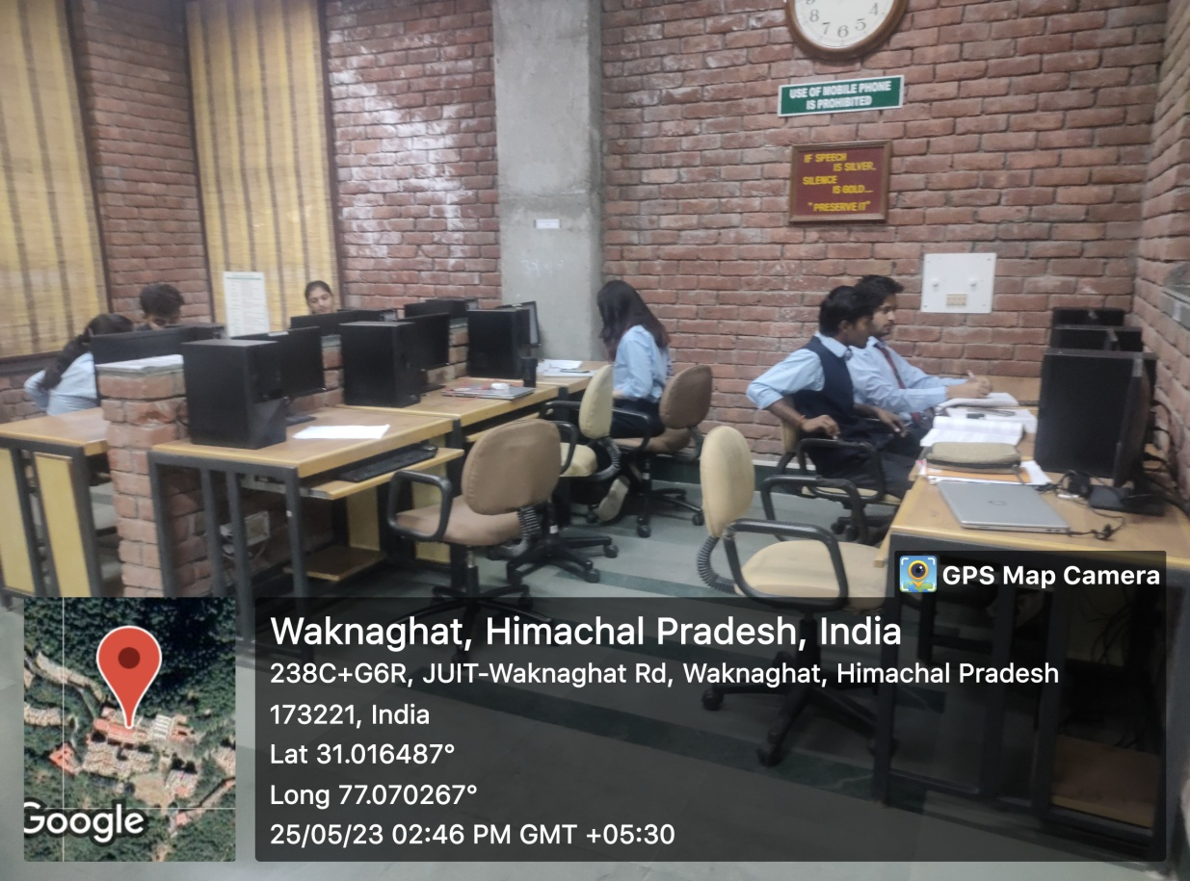

**Photocopier Facility**

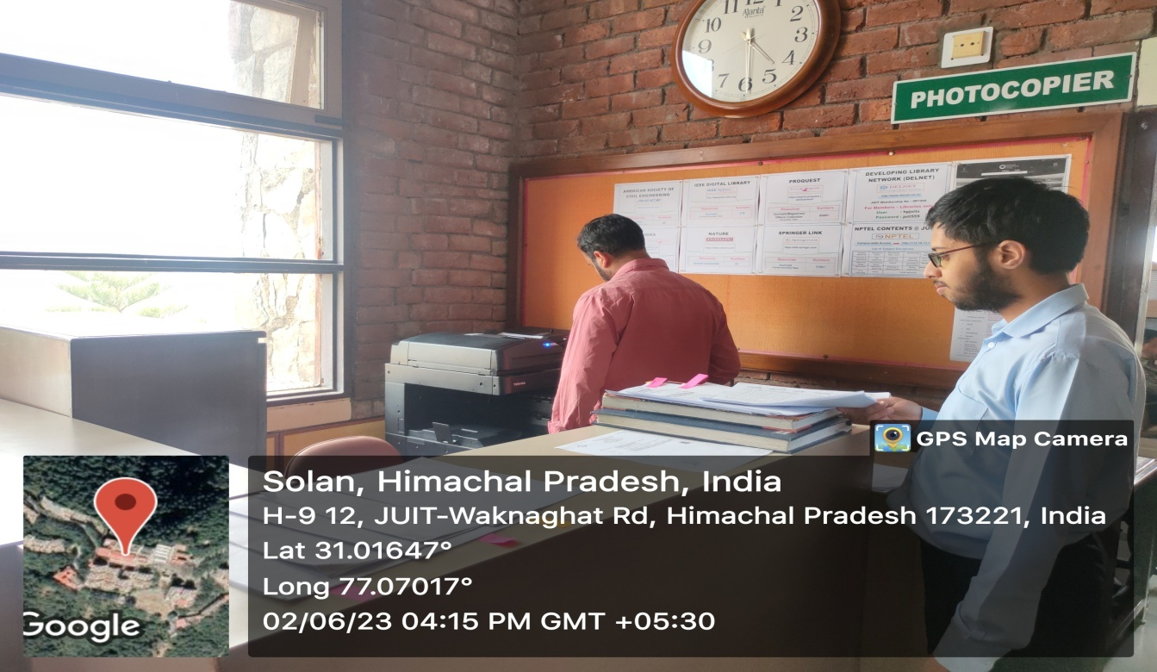

**Scanner for users in library**

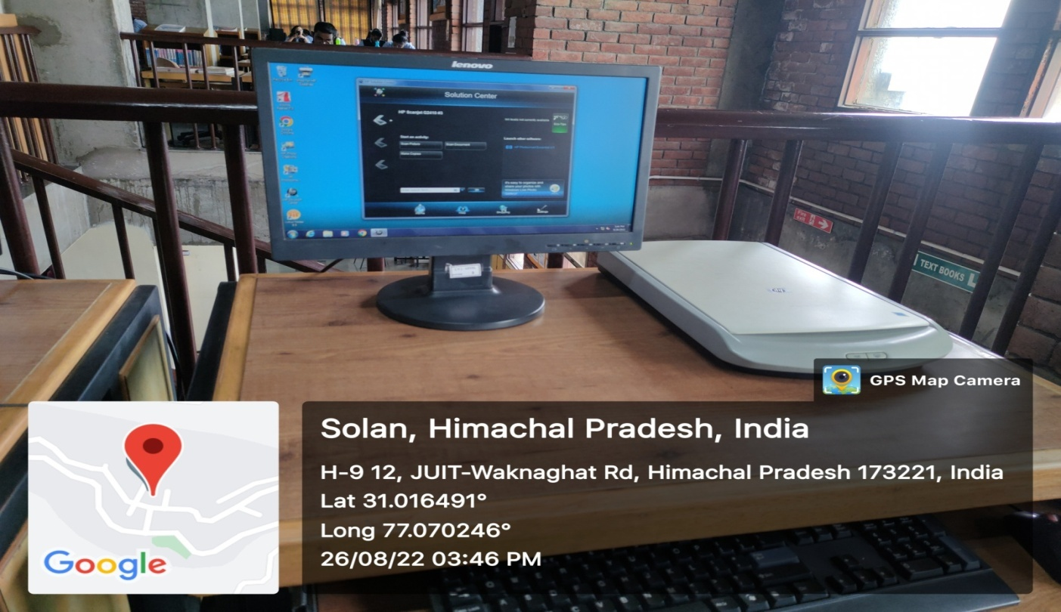

**Lockers for Research Scholars**

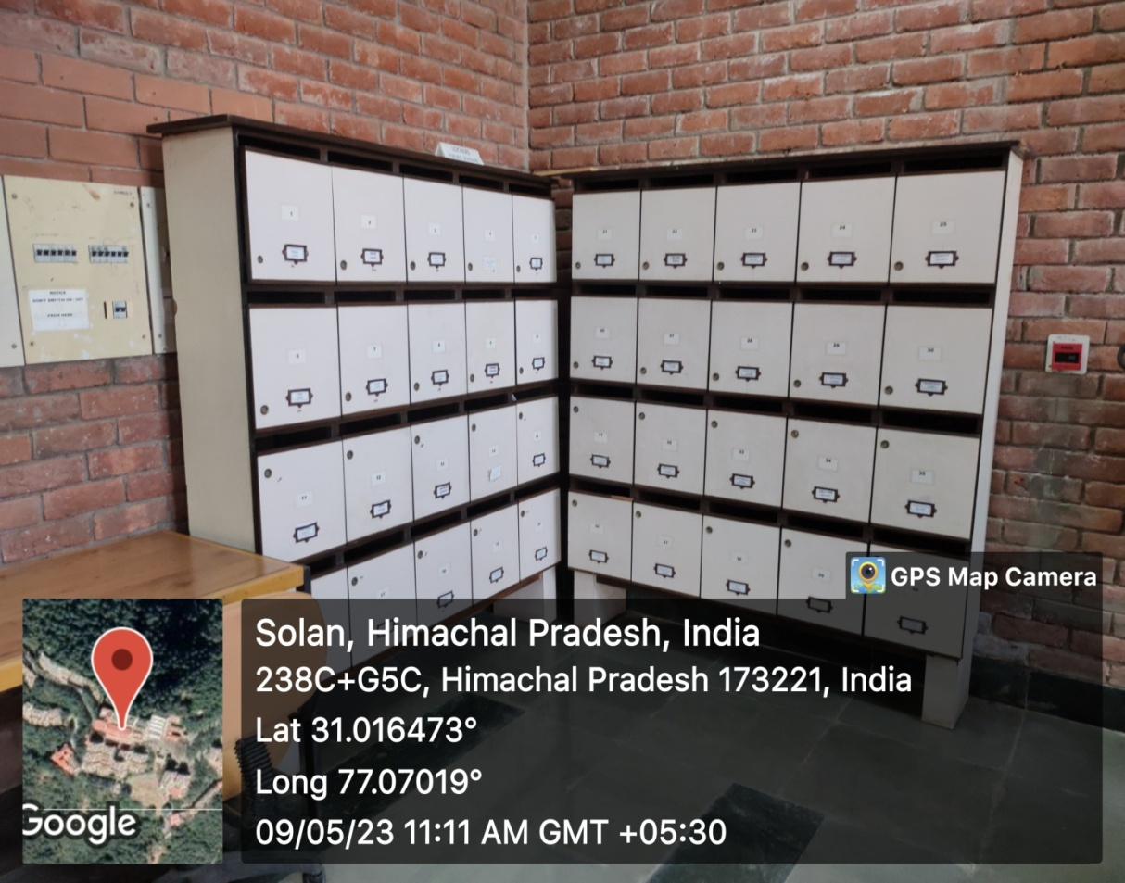

**Book Racks (Shelves)**

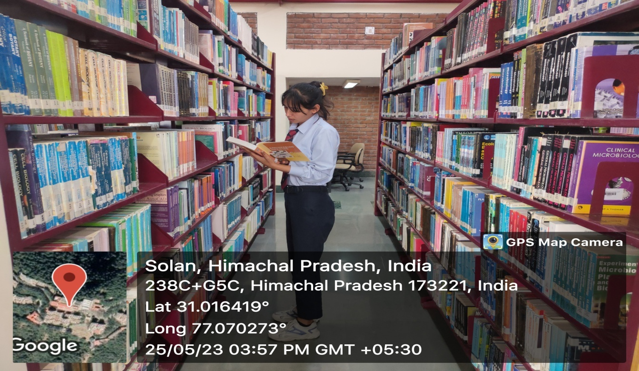

**Suggestion Box**

